02.06 Module Two Project
Directions
Now that you have an understanding of using functions and operations with numerical and non-numerical data, it's time to show your instructor and yourself what you can do with them! You will use the software development life cycle (SDLC) to create a working program of your choice that will perform calculations with user input. Your program can include any Python skills and functions you have learned up to this point.
This assignment has five steps.
Step One: Planning & Analysis
Read the options carefully and choose ONE as the basis of your project.
Option 1 – Wish List
Have your eye on a new gadget? A new game? Maybe some new clothes? Well, now's your chance to create a program that calculates the total cost of three items on your wish list, including tax and shipping.
Follow these steps to begin your planning:
- Create a wish list by selecting at least three items you want.
- Do your research. Find the online store(s) where you can purchase your wish list items and record the price of each one.
- Think about what user input is required for others to use your program.
- Think about how you will write an equation to calculate the subtotal of your three items, the tax, and the total purchase cost with tax and shipping. Note: Use 6.5% tax and a $5.99 flat-rate shipping fee for your program.
- The output must include the following: name of each item, item price, subtotal for items, total amount of tax, shipping fee, and total purchase cost with tax and shipping.
Use this table to organize your data:
Item | Price

Step Two: Design
It's time to design your program by writing pseudocode. Your outline must include the following elements:

- Input statements
  - Ask the user for at least three numeric values.
  - Show proper use of the int() and float() functions.
  - Calculations required to achieve correct output.
  - Use proper order of operations.
  - Use any appropriate math functions.
  - Output statements
  - Create clear and well organized output to share the data and results of the calculations.
  - Show proper use of the str() function.

Insert your pseudocode here:

Step Three: Coding

Use the following guidelines to code your program:

  - To code the program, use the Python IDLE.
  - Using comments, type a heading that includes your name, today's date, and a short description of the program.
  - Follow the Python style conventions regarding indentation and the use of white space in your program.
  - Use meaningful names for all variables.

Example of expected output: The output for your program should resemble the following screenshot. Your specific results will vary, depending on the choices you make, and the input provided.

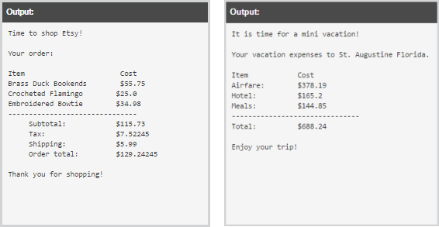
Insert a copy of your code from the IDLE here:

Step Four: Testing
Run your code and evaluate the output. Then, answer the following questions in the testing chart. Use two to three meaningful sentences to answer each question.
Testing Question | Response
What bugs did you identify in your code?

How did you fix the bugs?

Step Five: Maintenance
Passionate programmers strive to improve their code! In two to three meaningful sentences, answer the following questions in the maintenance chart to consider the next steps of your program.
Maintenance Question | Response
What design and functionality improvements could you make to your program?

How can you get feedback on ways to improve your program?

How can you expand your program into a new, better program in the future?

What are potential bugs that users may possibly encounter if your program is expanded into a new program in the future?

